Acadia National Park

# Description

Acadia National Park protects the natural beauty of the highest rocky headlands along the Atlantic coastline of the United States, an abundance of habitats, and a rich cultural heritage. At 3.5 million visits a year, it's one of the top 10 most-visited national parks in the United States. Visitors enjoy 27 miles of historic motor roads, 158 miles of hiking trails, and 45 miles of carriage roads.

# Weather Description

Located on Mount Desert Island in Maine, Acadia experiences all four seasons. Summer temperatures range from 45-90F (7-30C). Fall temperatures range from 30-70F (-1-21C). Typically the first frost is in mid-October and first snowfall begins in November and can continue through April with an average accumulation of 73 inches (185 cm). Winter temperatures range from 14-35F (-10 - 2C). Spring temperatures range from 30-70F (-1-21C).

# Description

Acadia National Park protects the natural beauty of the highest rocky headlands along the Atlantic coastline of the United States, an abundance of habitats, and a rich cultural heritage. At 3.5 million visits a year, it's one of the top 10 most-visited national parks in the United States. Visitors enjoy 27 miles of historic motor roads, 158 miles of hiking trails, and 45 miles of carriage roads.

Birdwatching

Rock Climbing

Saltwater Fishing

Shopping

Snowmobiling

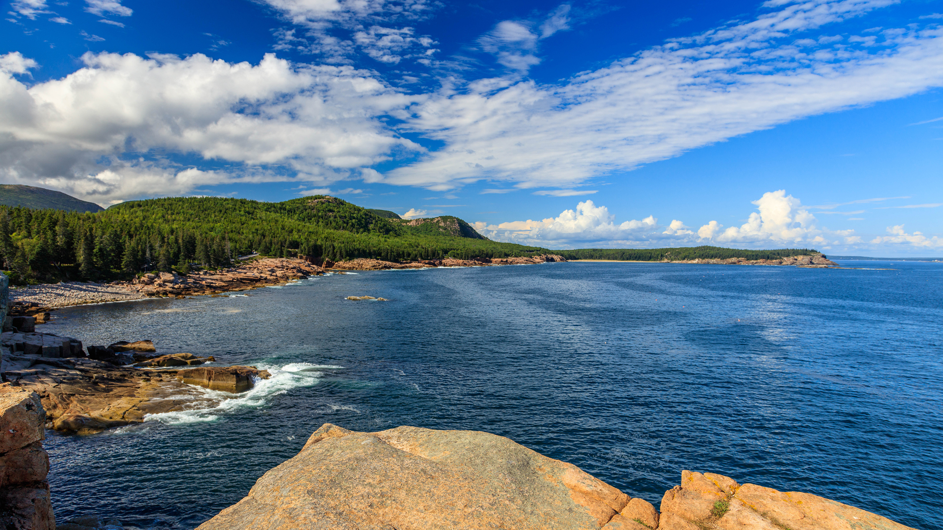

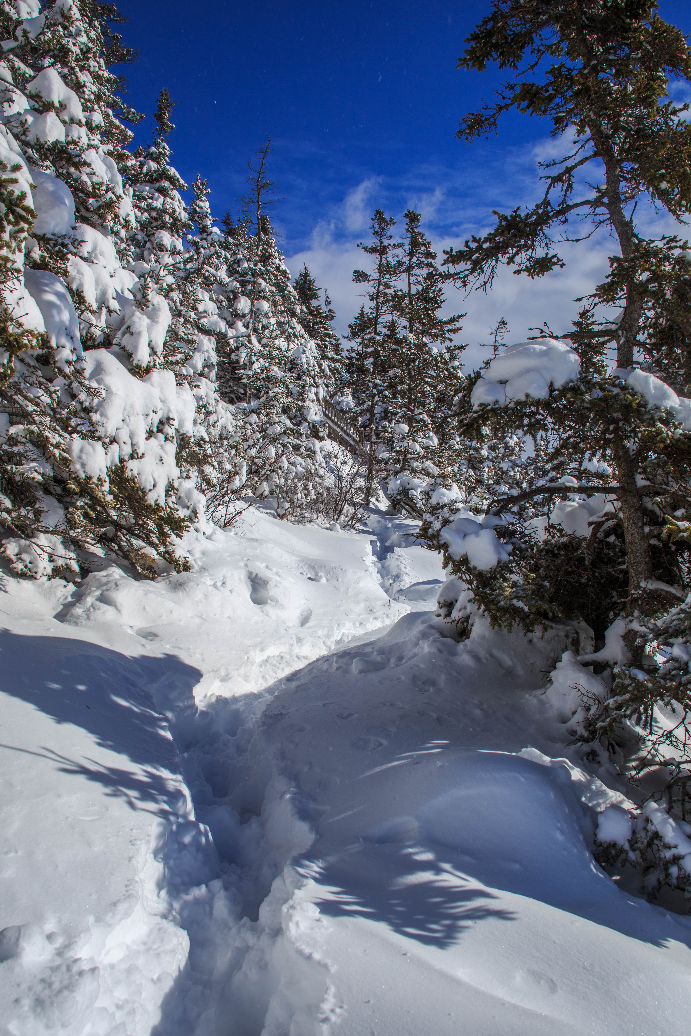

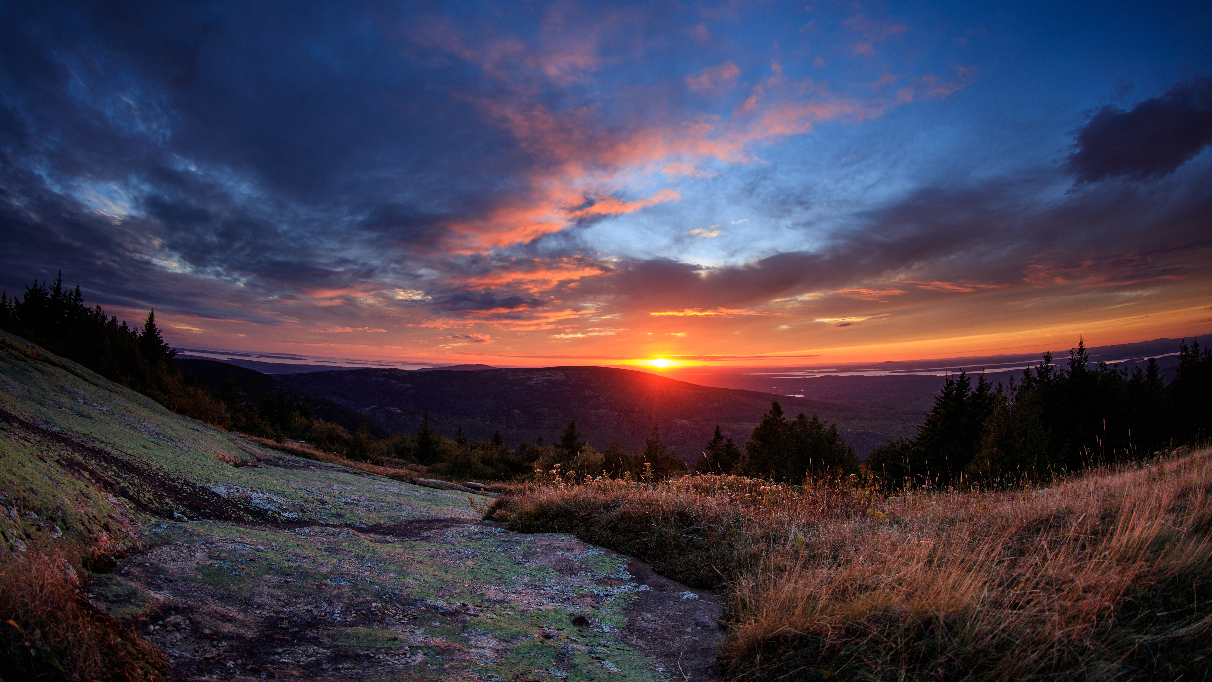

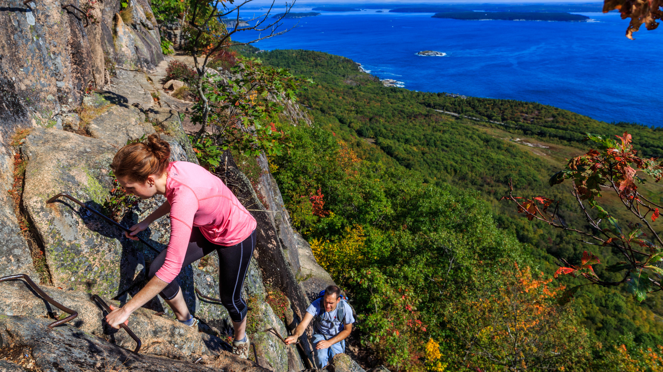

# Park Operating Hours

Acadia National Park is open year-round. Check our website for park facilities operating hours, such as Hulls Cove Visitor Center.

# Contact Information

## Address

25 Visitor Center Road  
Hulls Cove Visitor Center  
ME  
04609

# Website Info

https://national-parks-1150.azurewebsites.net/api/ACAD

Rocky Mountain National Park

# Description

Rocky Mountain National Park's 415 square miles (265,807 acres) encompasses a spectacular range of mountain environments. From meadows found in the montane life zone to the glistening lakes in the subalpine zone and to the mountain peaks located in the alpine zone, there is something for everyone to discover. Along the way explore over 300 miles of hiking trails and incredible wildlife viewing.

# Weather Description

Winter (Dec–Mar): cold weather, deep snow at higher elevations, and seasonal closures of facilities and roads. Spring (April–May): unpredictable weather, with a mix of warm sunny days and cool days with heavy snow and rain. Many trails are still snow-covered. Trail Ridge Road opens in late May. Summer (Jun–Aug): warmer weather, thunderstorms, and wildflowers. Most park roads and facilities are open. Fall (Sep–Nov): crisp air, blue skies, fall colors, and the elk rut. Trail Ridge Road closes mid-October.

# Description

Rocky Mountain National Park's 415 square miles (265,807 acres) encompasses a spectacular range of mountain environments. From meadows found in the montane life zone to the glistening lakes in the subalpine zone and to the mountain peaks located in the alpine zone, there is something for everyone to discover. Along the way explore over 300 miles of hiking trails and incredible wildlife viewing.

Astronomy

Car or Front Country Camping

Junior Ranger Program

Shopping

Snow Tubing

Wildlife Watching

# Park Operating Hours

While certain roads and facilities may be closed, the park is open 24 hours a day, 365 days a year.

# Contact Information

## Address

1000 US Hwy 36  
CO  
80517

# Website Info

https://national-parks-1150.azurewebsites.net/api/ROMO

Hawaiʻi Volcanoes National Park

# Description

Hawai‘i Volcanoes National Park protects some of the most unique geological, biological, and cherished cultural landscapes in the world. Extending from sea level to 13,681 feet, the park encompasses the summits of two of the world's most active volcanoes - Kīlauea and Mauna Loa - and is a designated International Biosphere Reserve and UNESCO World Heritage Site.

# Weather Description

The weather at Kīlauea's summit (4000' elevation) varies daily and may be rainy and chilly any time of the year. Temperature varies by elevation. At the summit of the volcano, temperatures may be 12 to 15 degrees cooler than at sea level. The coastal plain at the end of Chain of Craters Road, where lava crossed the road in 2003, is often hot, dry, and windy with the possibility of passing showers.

# Description

Hawai‘i Volcanoes National Park protects some of the most unique geological, biological, and cherished cultural landscapes in the world. Extending from sea level to 13,681 feet, the park encompasses the summits of two of the world's most active volcanoes - Kīlauea and Mauna Loa - and is a designated International Biosphere Reserve and UNESCO World Heritage Site.

Bookstore and Park Store

Camping

Car or Front Country Camping

Gift Shop and Souvenirs

Museum Exhibits

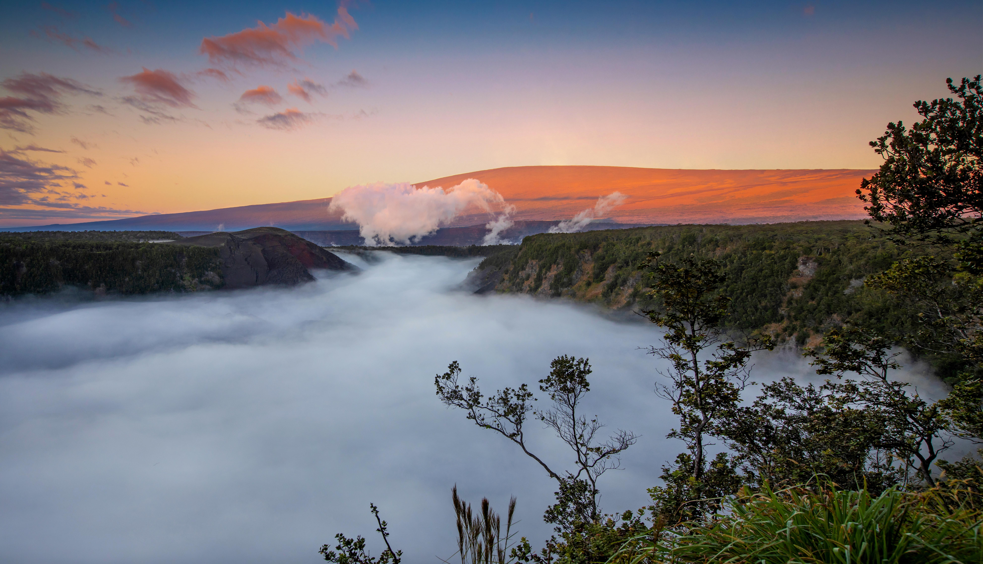

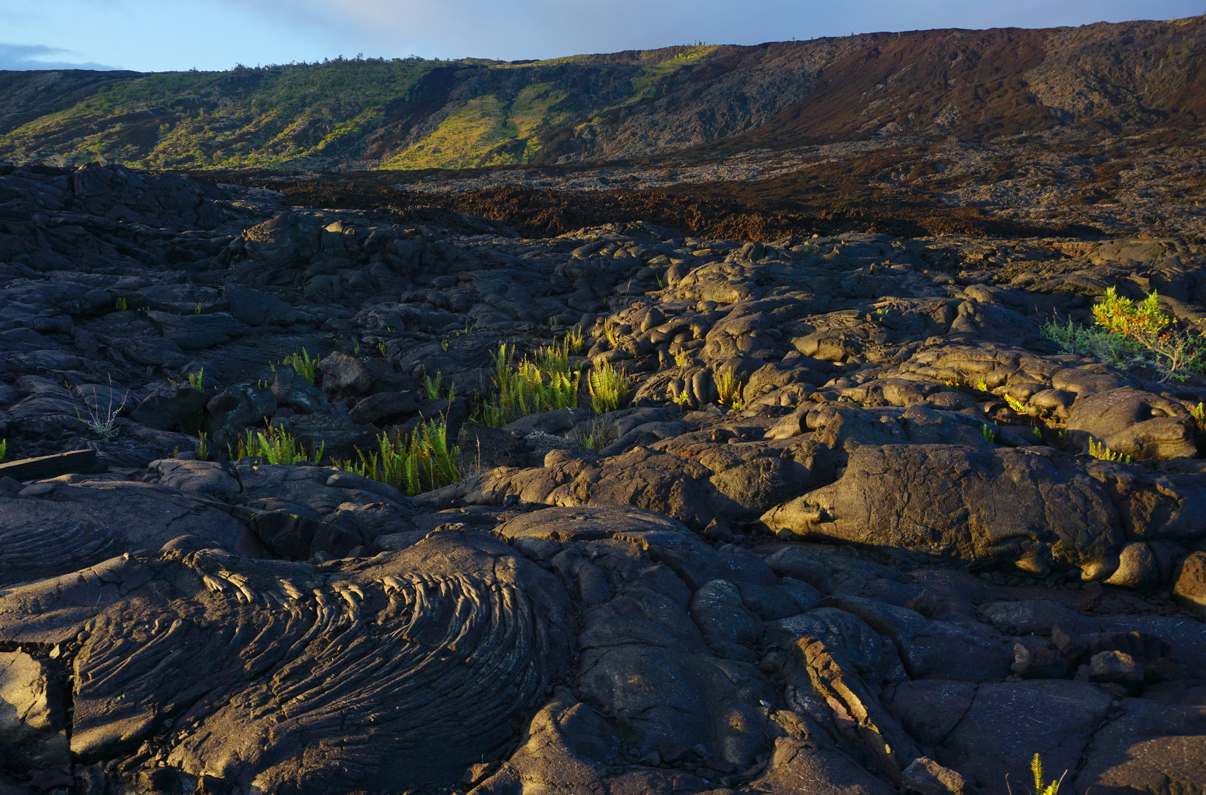

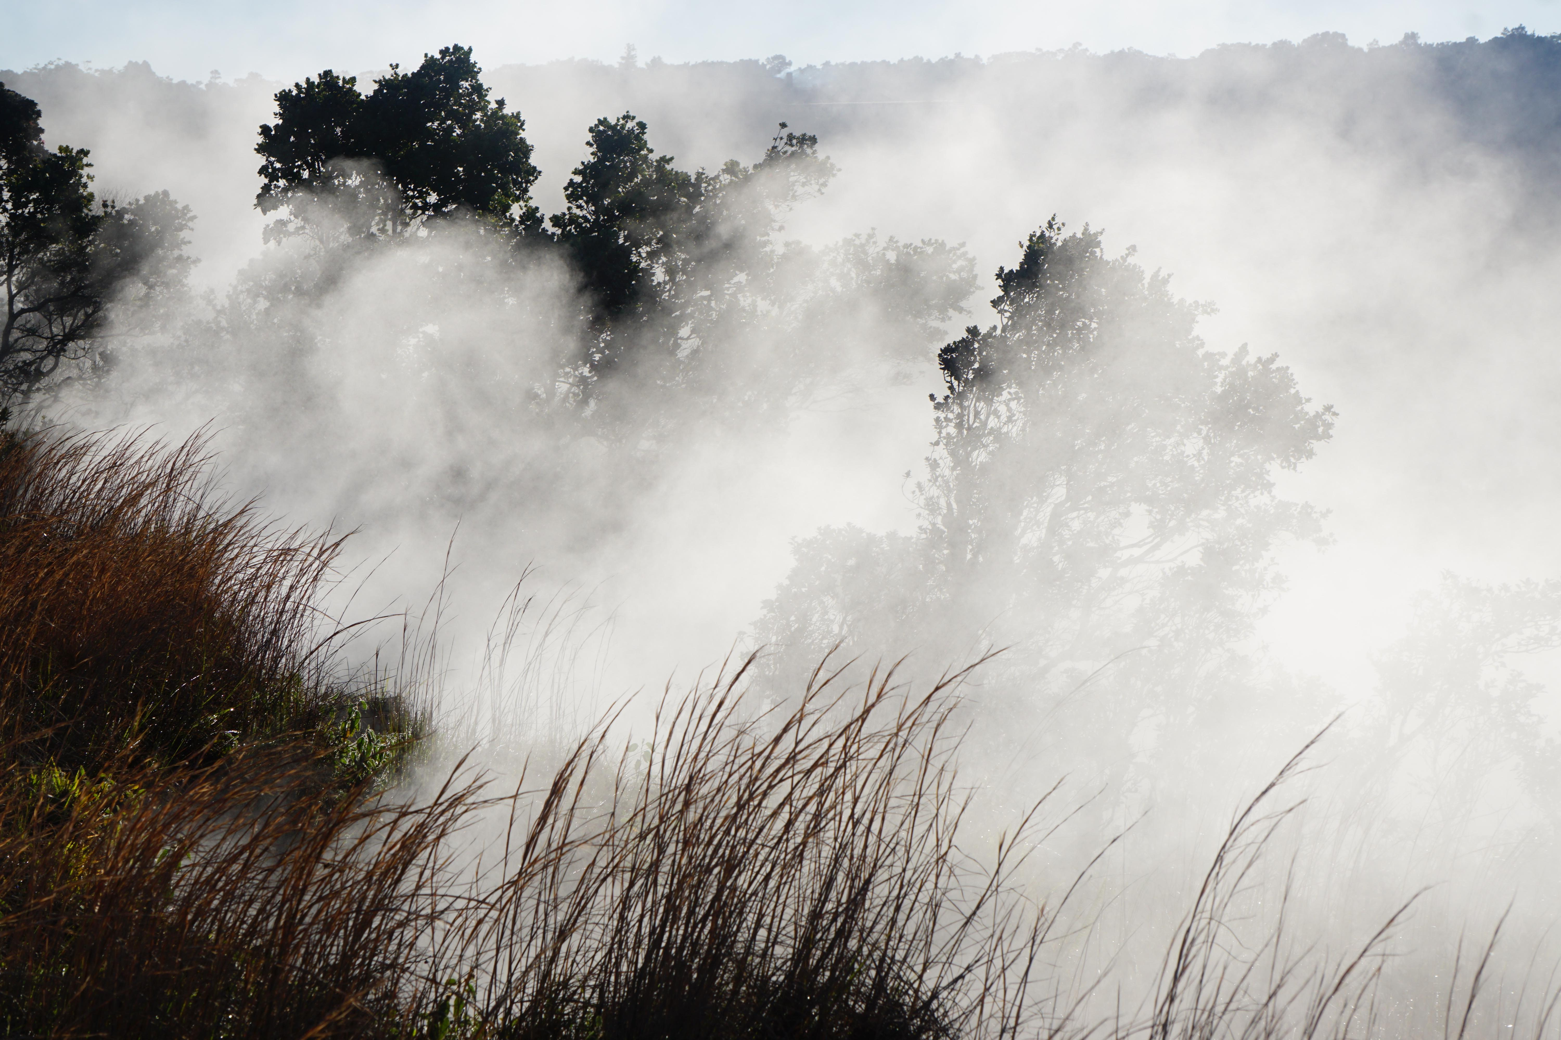

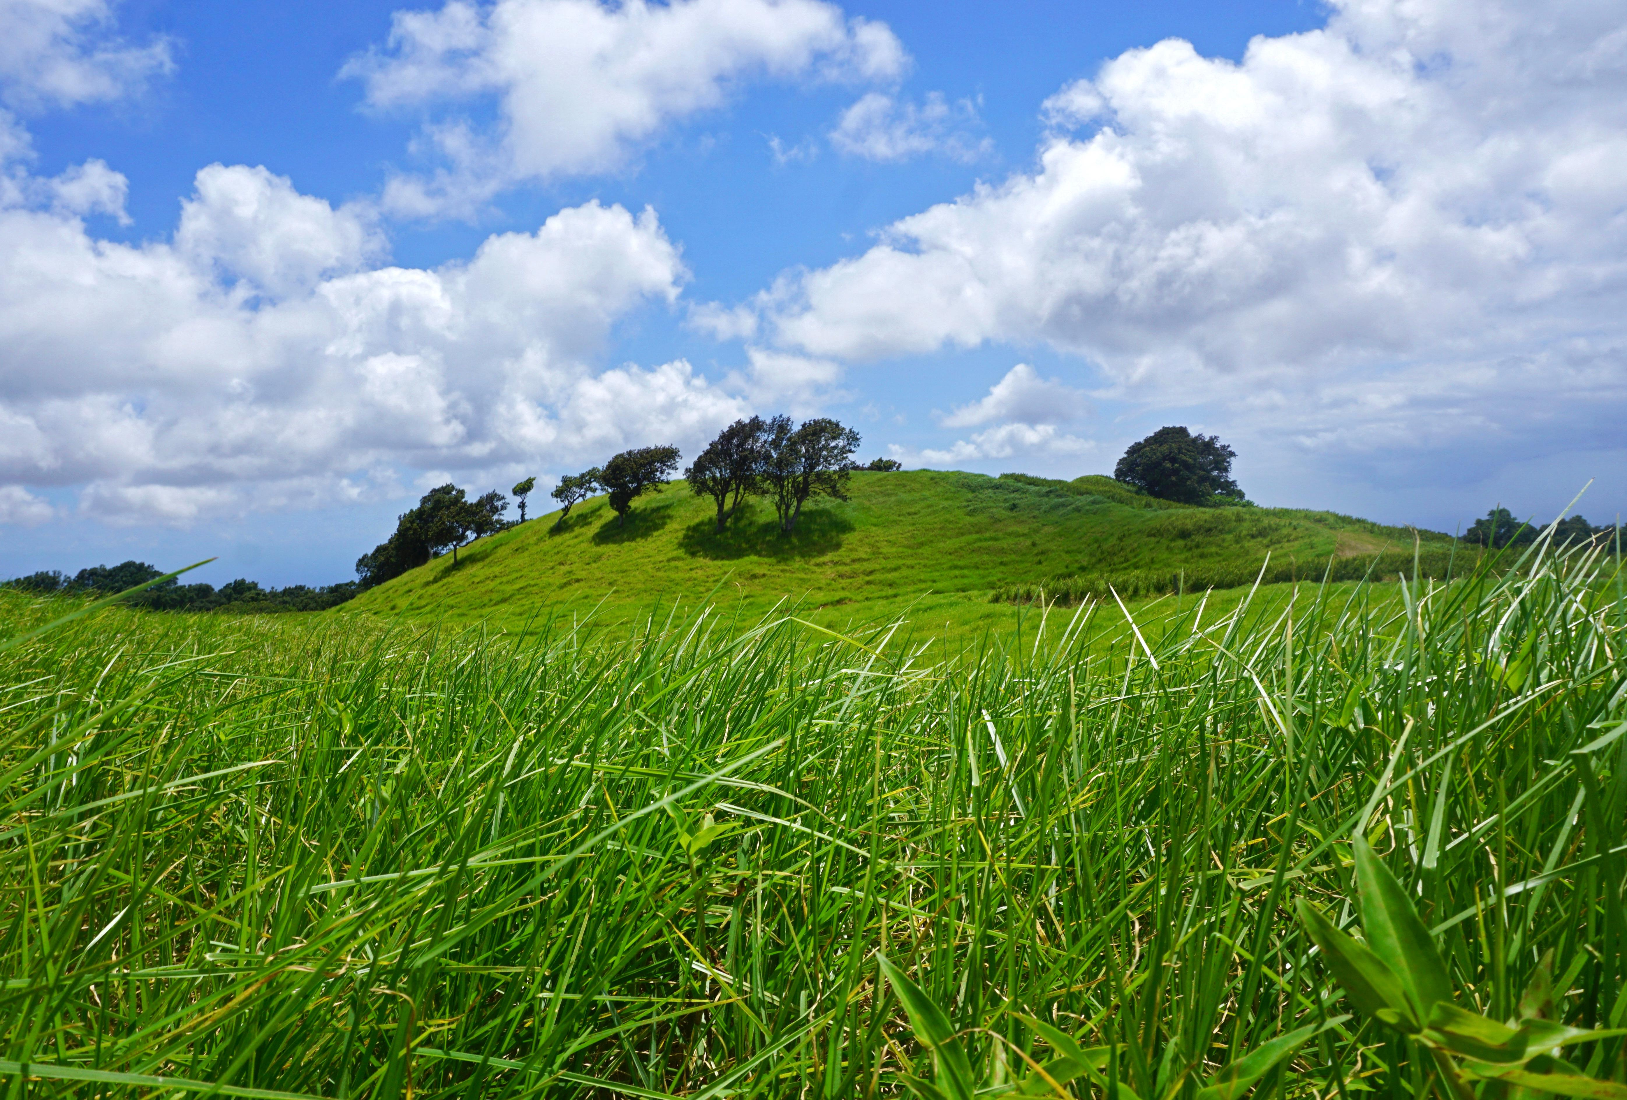

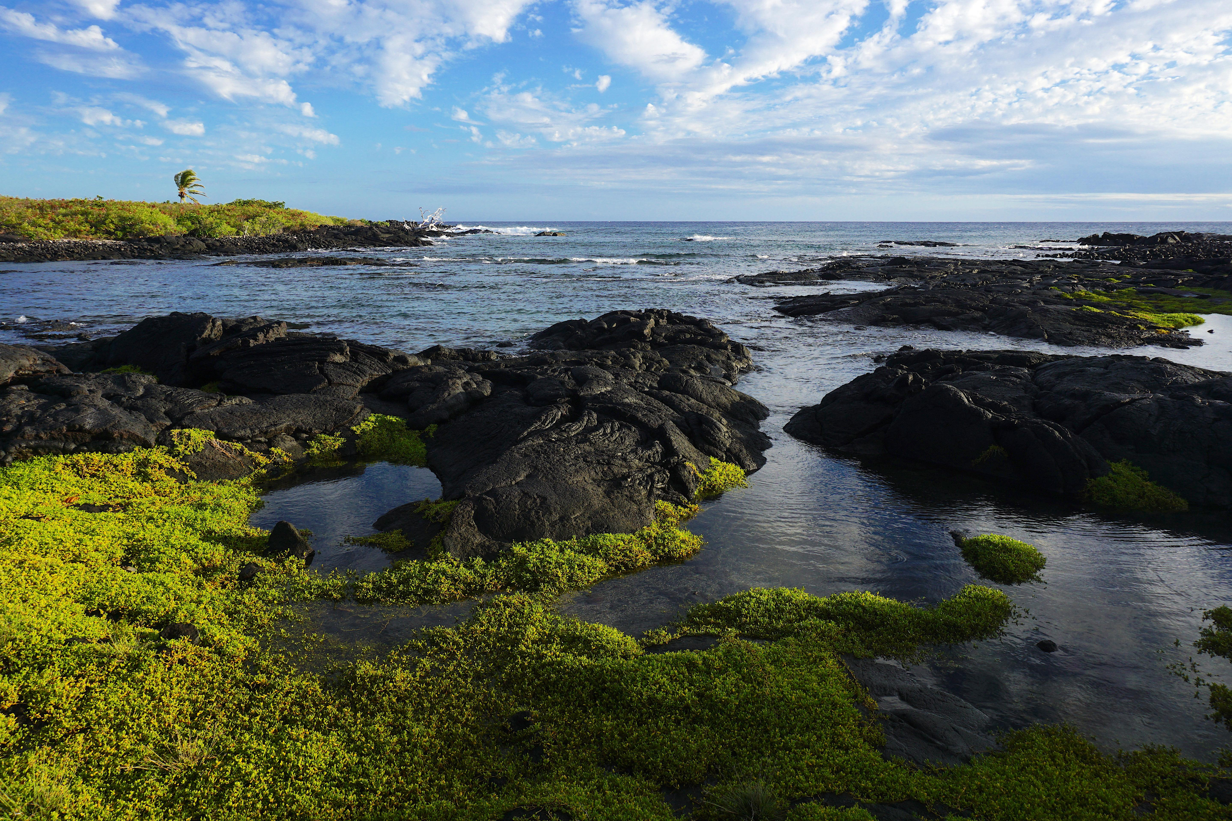

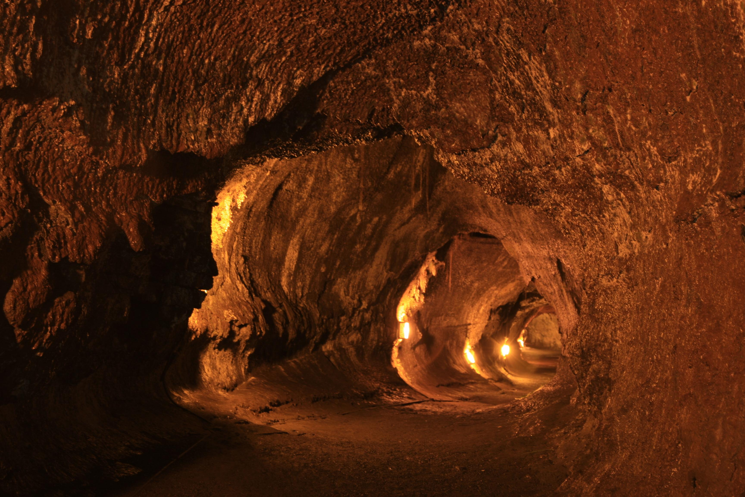

# Park Operating Hours

Hawai‘i Volcanoes National Park is open 7 days a week, 24 hours a day including holidays.

# Contact Information

## Address

1 Crater Rim Drive  
HI  
96718

# Website Info

https://national-parks-1150.azurewebsites.net/api/HAVO

Great Basin National Park

# Description

From the 13,063-foot summit of Wheeler Peak, to the sage-covered foothills, Great Basin National Park is a place to sample the stunning diversity of the larger Great Basin region. Come and partake of the solitude of the wilderness, walk among ancient bristlecone pines, bask in the darkest of night skies, and explore mysterious subterranean passages. There's a whole lot more than just desert here!

# Weather Description

There is almost an 8,000 ft (2,400 m) difference in elevation between Wheeler Peak and the valley floor. Weather conditions in the park vary with elevation. In late spring and early summer, days in the valley may be hot, yet the snow pack may not have melted in the higher elevations. The Great Basin is a desert, with low relative humidity and sharp drops in temperature at night. In the summer, fierce afternoon thunderstorms are common. It can snow any time of the year at high elevations.

# Description

From the 13,063-foot summit of Wheeler Peak, to the sage-covered foothills, Great Basin National Park is a place to sample the stunning diversity of the larger Great Basin region. Come and partake of the solitude of the wilderness, walk among ancient bristlecone pines, bask in the darkest of night skies, and explore mysterious subterranean passages. There's a whole lot more than just desert here!

Climbing

Guided Tours

Picnicking

RV Camping

Road Biking

Shopping

Skiing

Stargazing

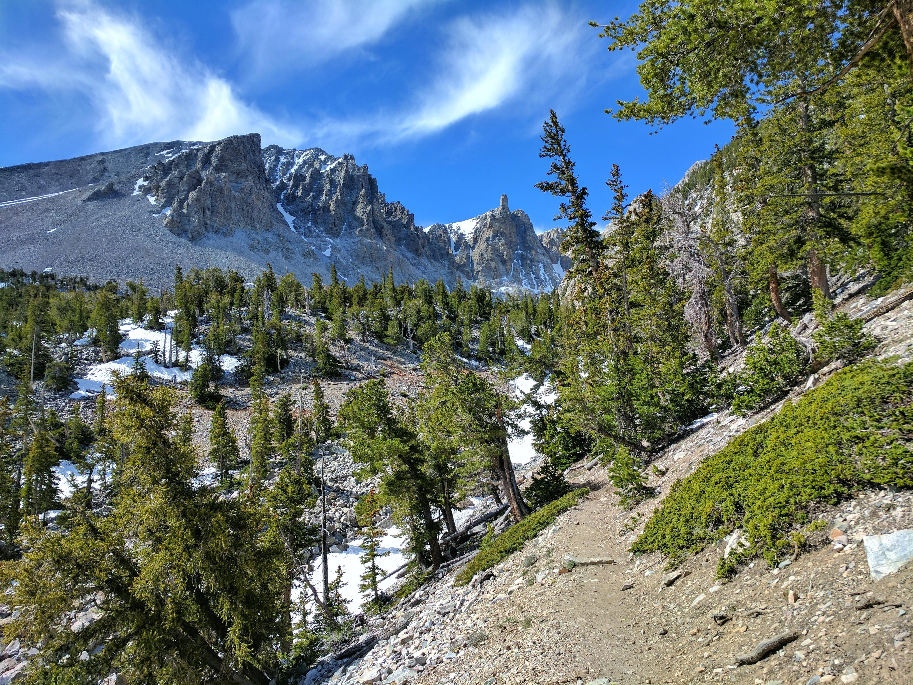

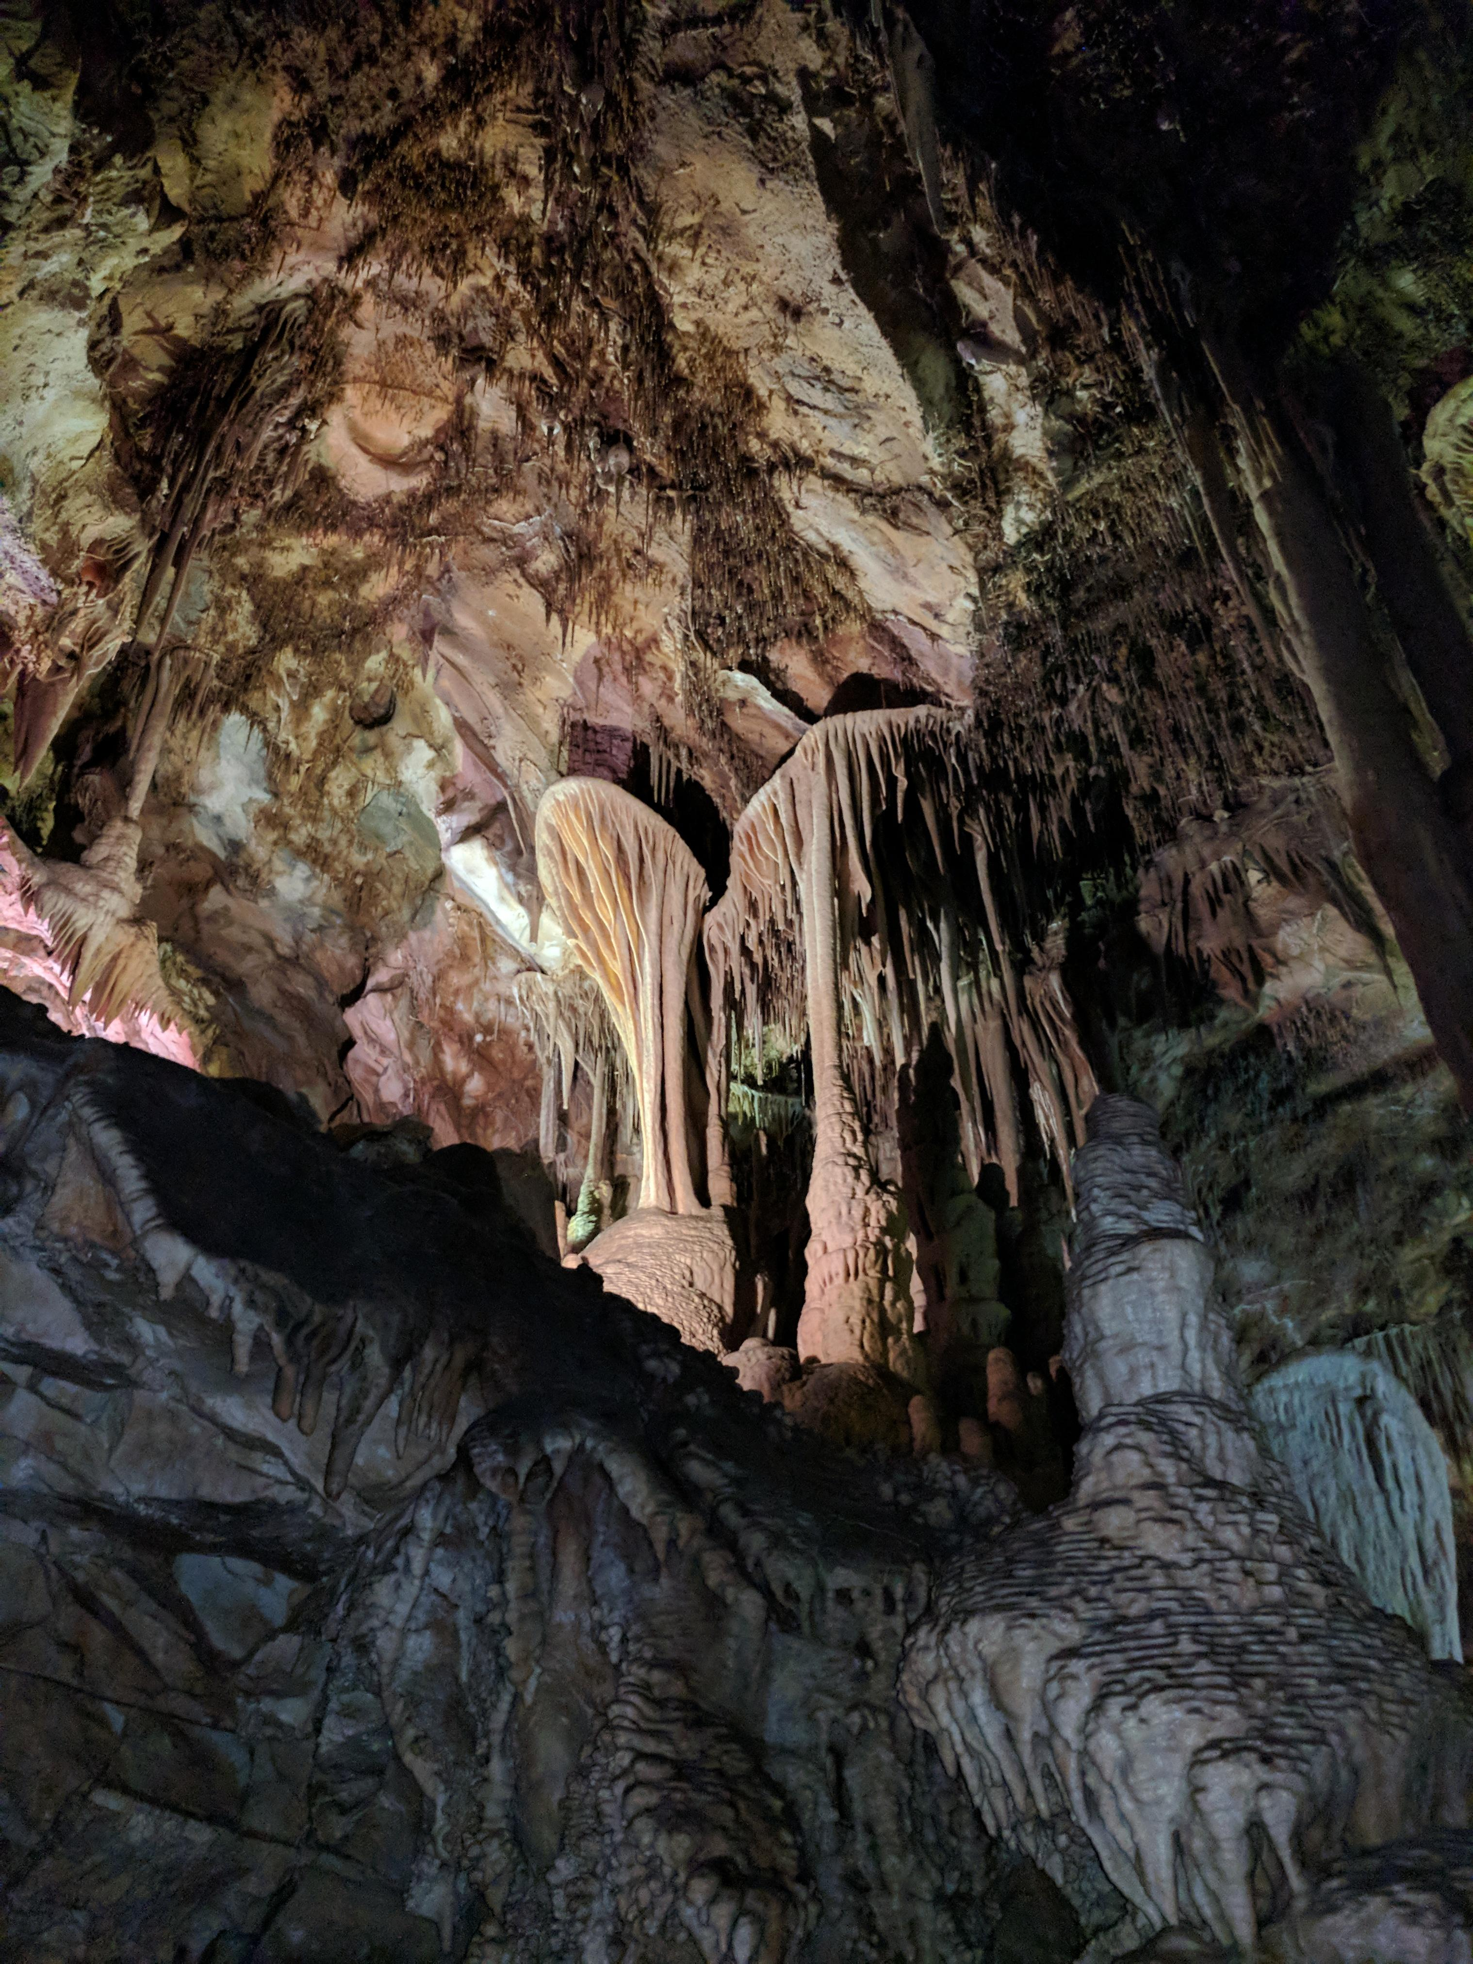

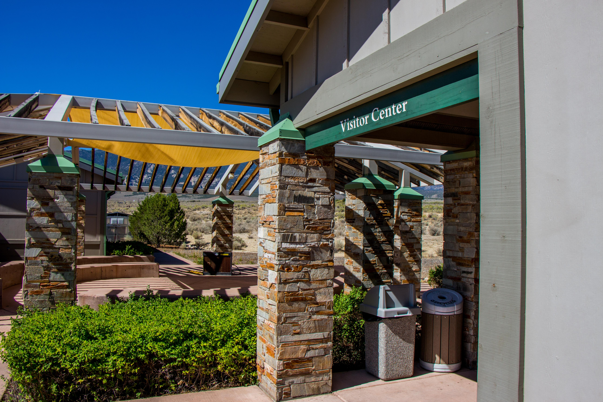

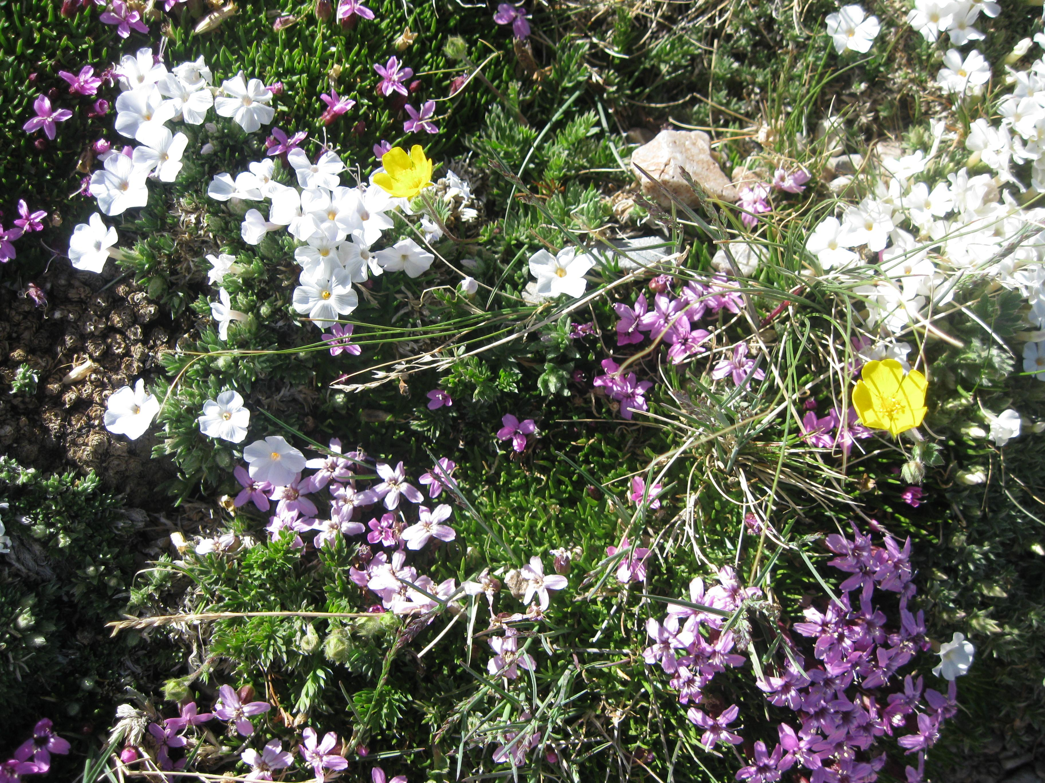



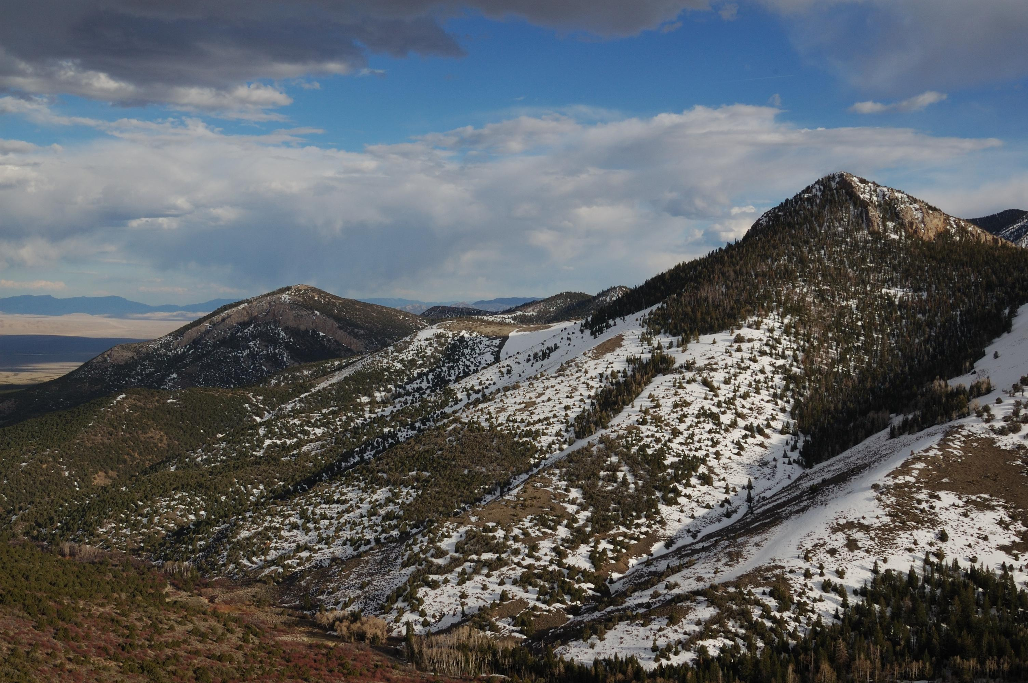

# Park Operating Hours

Park Grounds and Trails

# Contact Information

## Address

Lehman Caves Visitor Center  
Nevada 488  
NV  
89311

# Website Info

https://national-parks-1150.azurewebsites.net/api/GRBA

Crater Lake National Park

# Description

Crater Lake inspires awe. Native Americans witnessed its formation 7,700 years ago, when a violent eruption triggered the collapse of a tall peak. Scientists marvel at its purity: fed by rain and snow, it’s the deepest lake in the USA and one of the most pristine on earth. Artists, photographers, and sightseers gaze in wonder at its blue water and stunning setting atop the Cascade Mountain Range.

# Weather Description

Summers at Crater Lake are short but sunny. July, August, and September are your best bets for warm, dry weather. In May, June, and October, sunny days alternate with periods of rain and snow. Winters at Crater Lake are long and snowy. Storms from the Pacific Ocean dump an annual average of 43 feet (13 meters) of snow at Park Headquarters. The park's tremendous snowfall is a result of its position at the crest of the Cascade Mountains.

# Description

Crater Lake inspires awe. Native Americans witnessed its formation 7,700 years ago, when a violent eruption triggered the collapse of a tall peak. Scientists marvel at its purity: fed by rain and snow, it’s the deepest lake in the USA and one of the most pristine on earth. Artists, photographers, and sightseers gaze in wonder at its blue water and stunning setting atop the Cascade Mountain Range.

Auto and ATV

Boat Tour

Bus/Shuttle Guided Tour

Dining

Junior Ranger Program

Shopping

Skiing

Snow Play

Snowshoeing

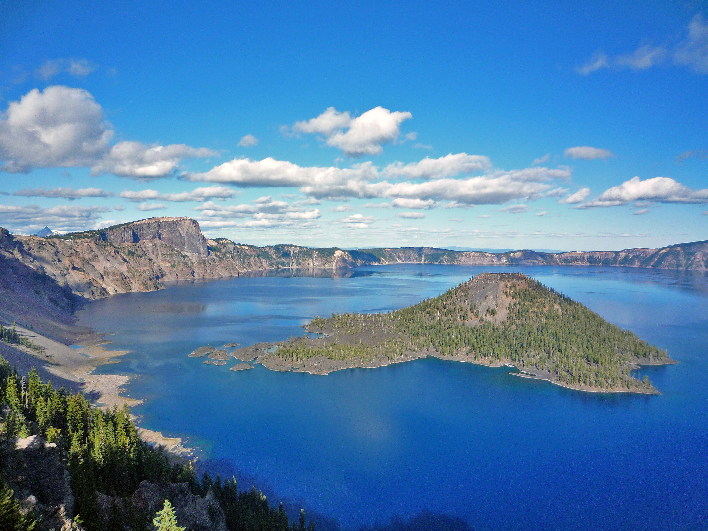

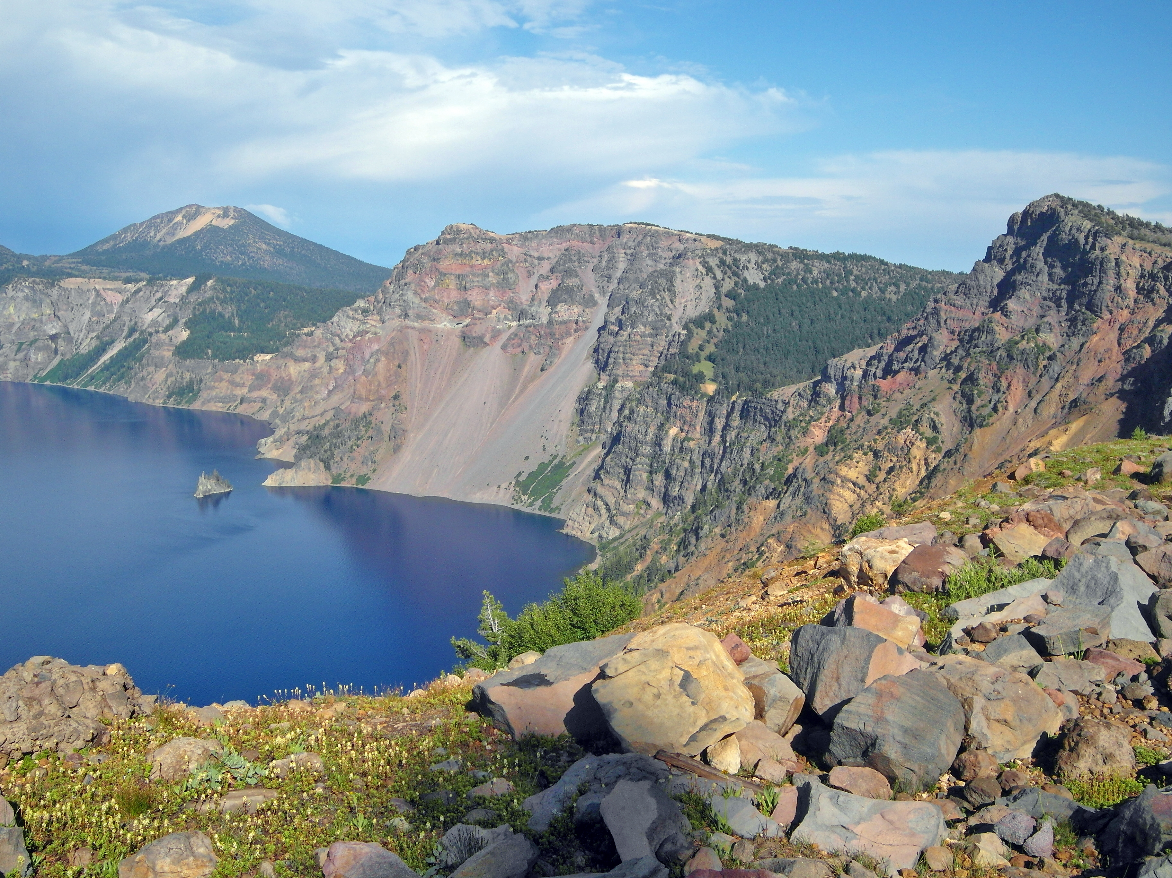

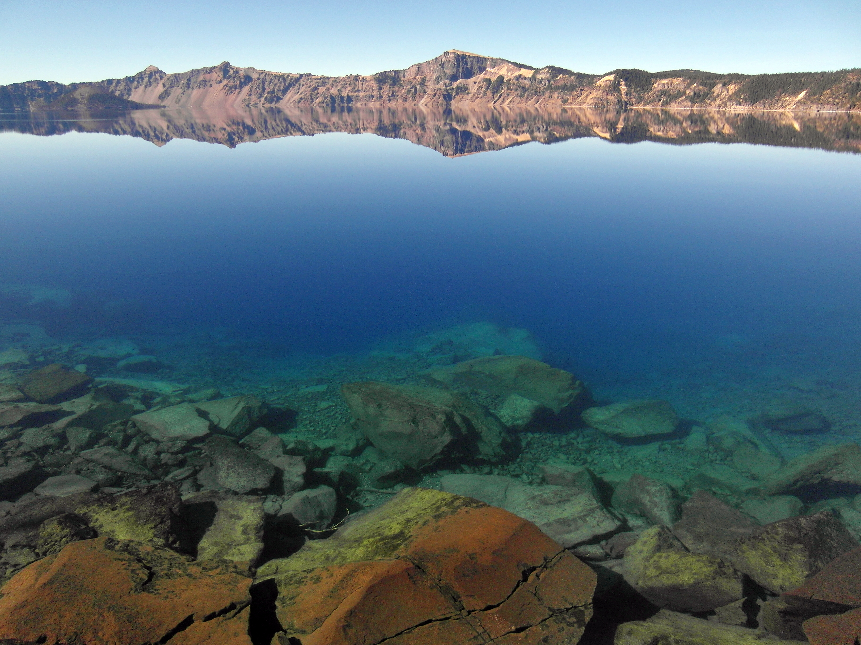

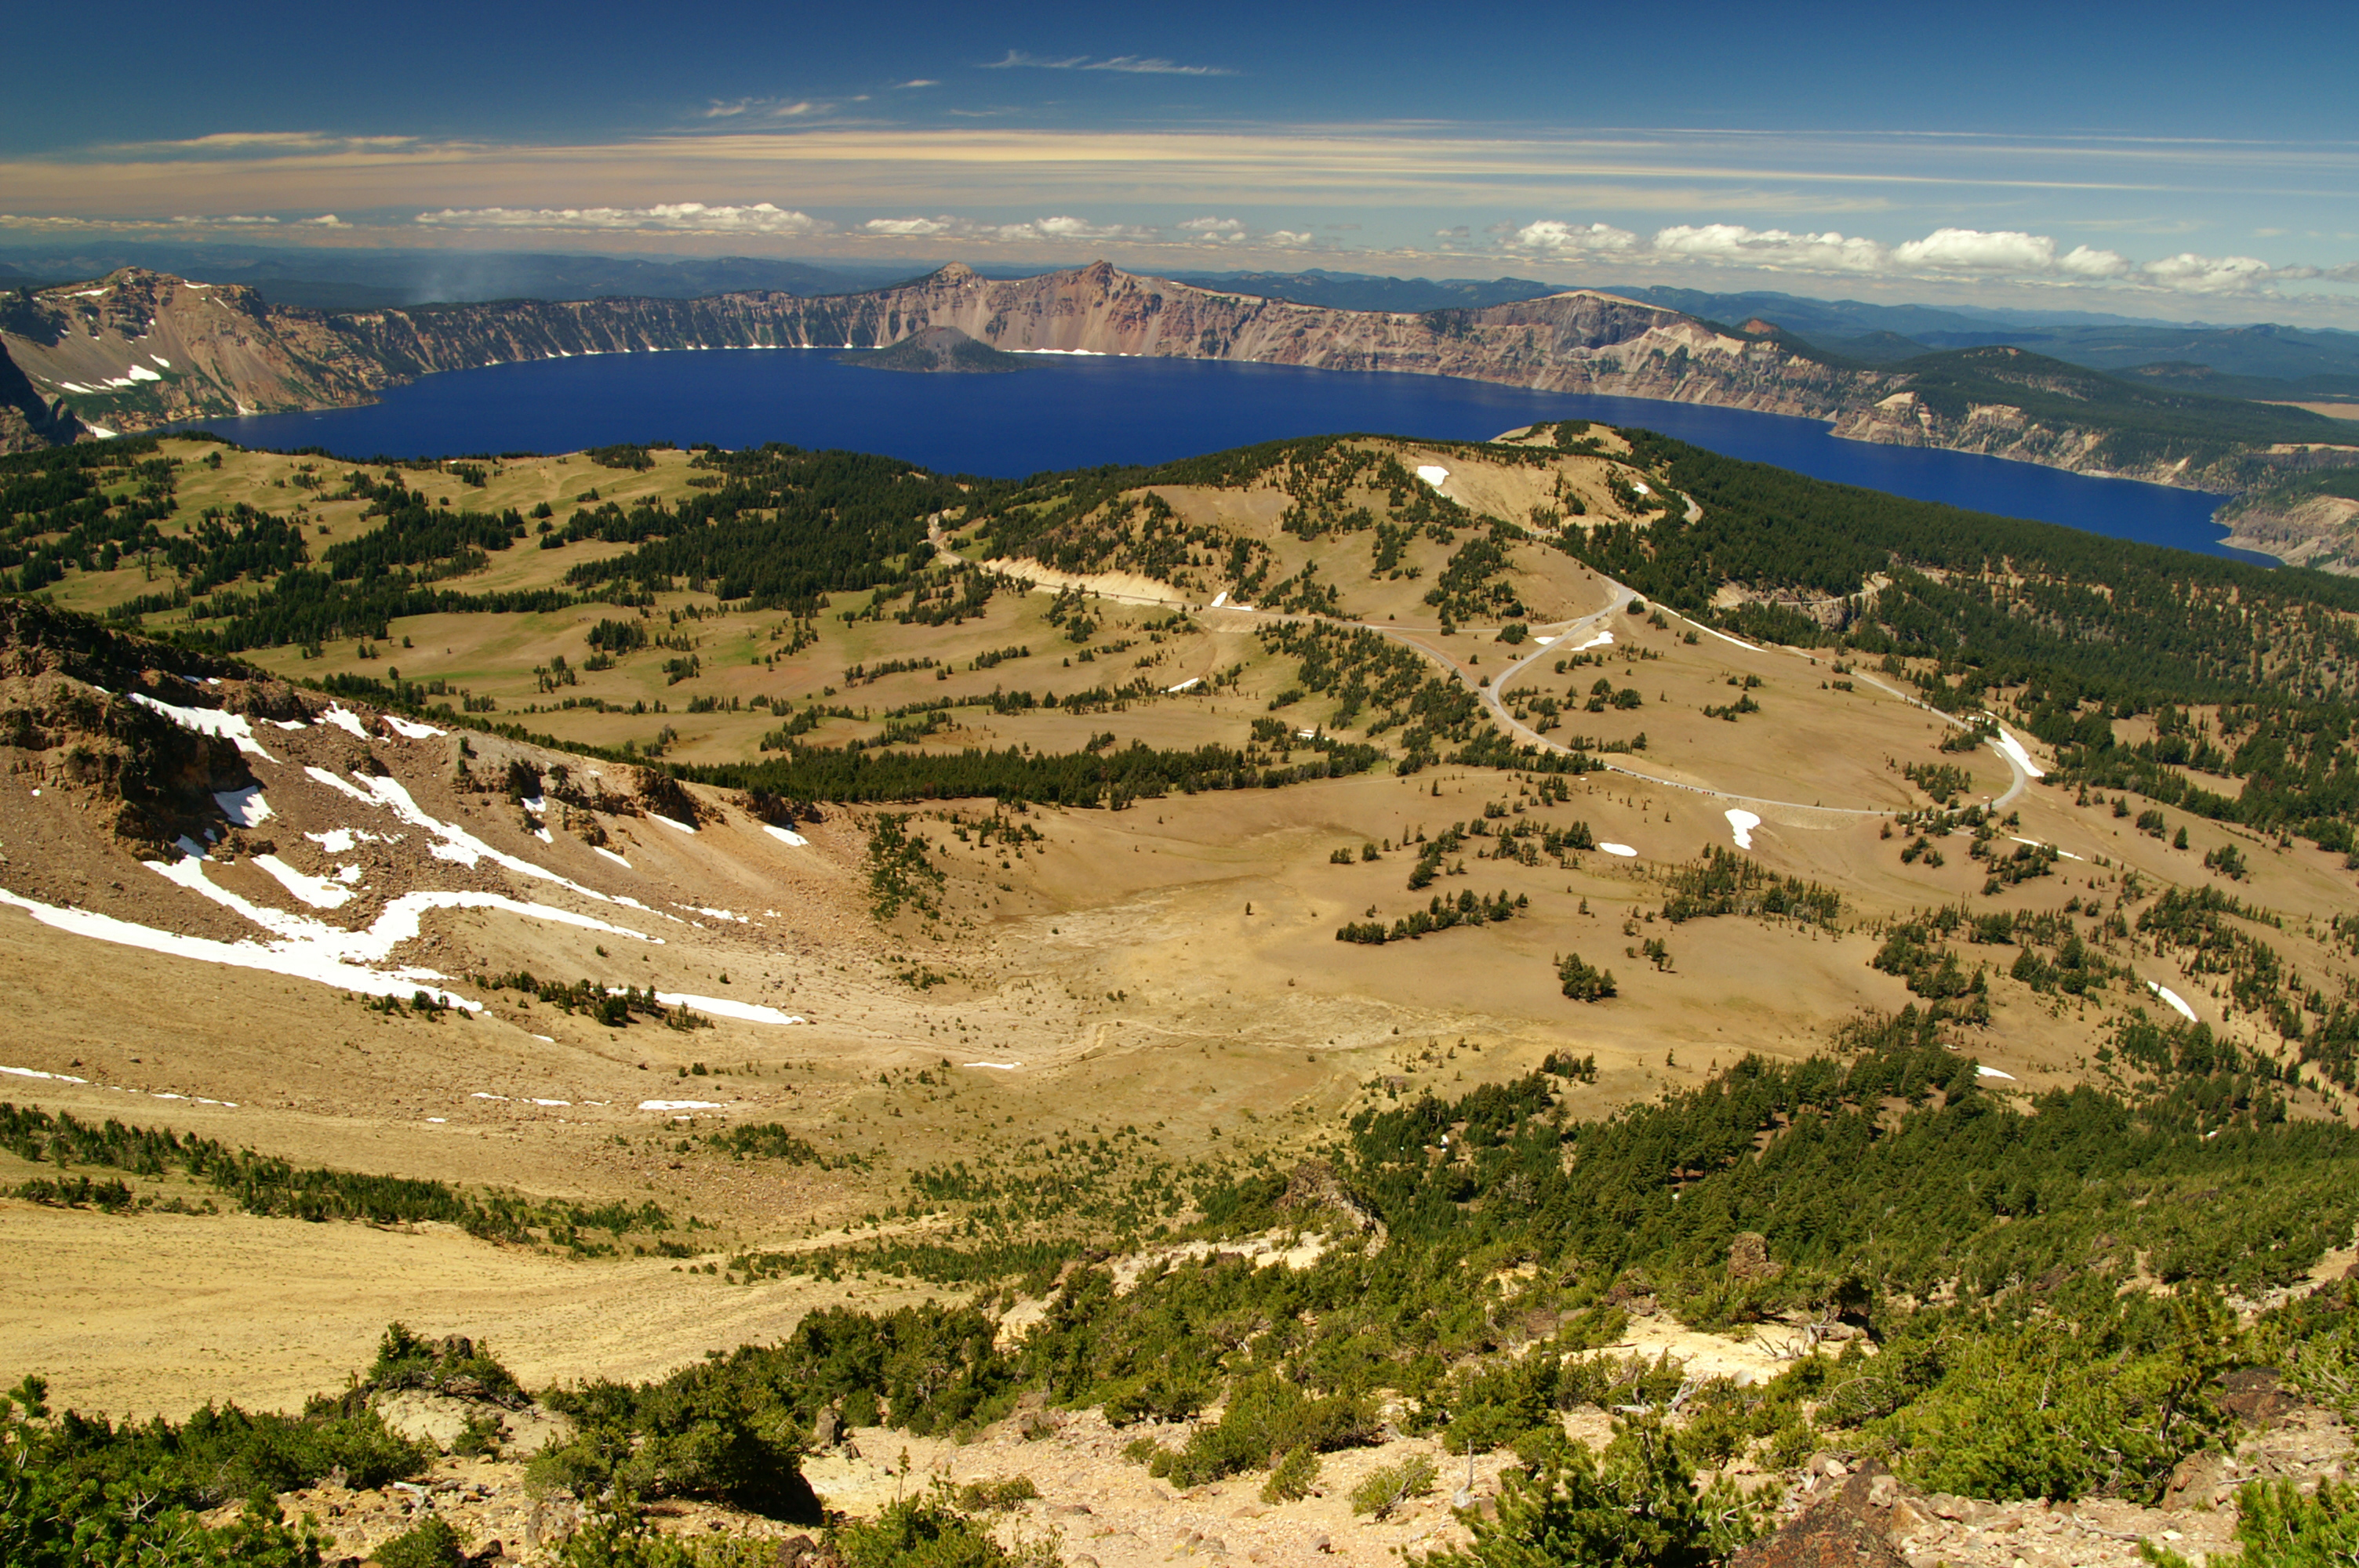

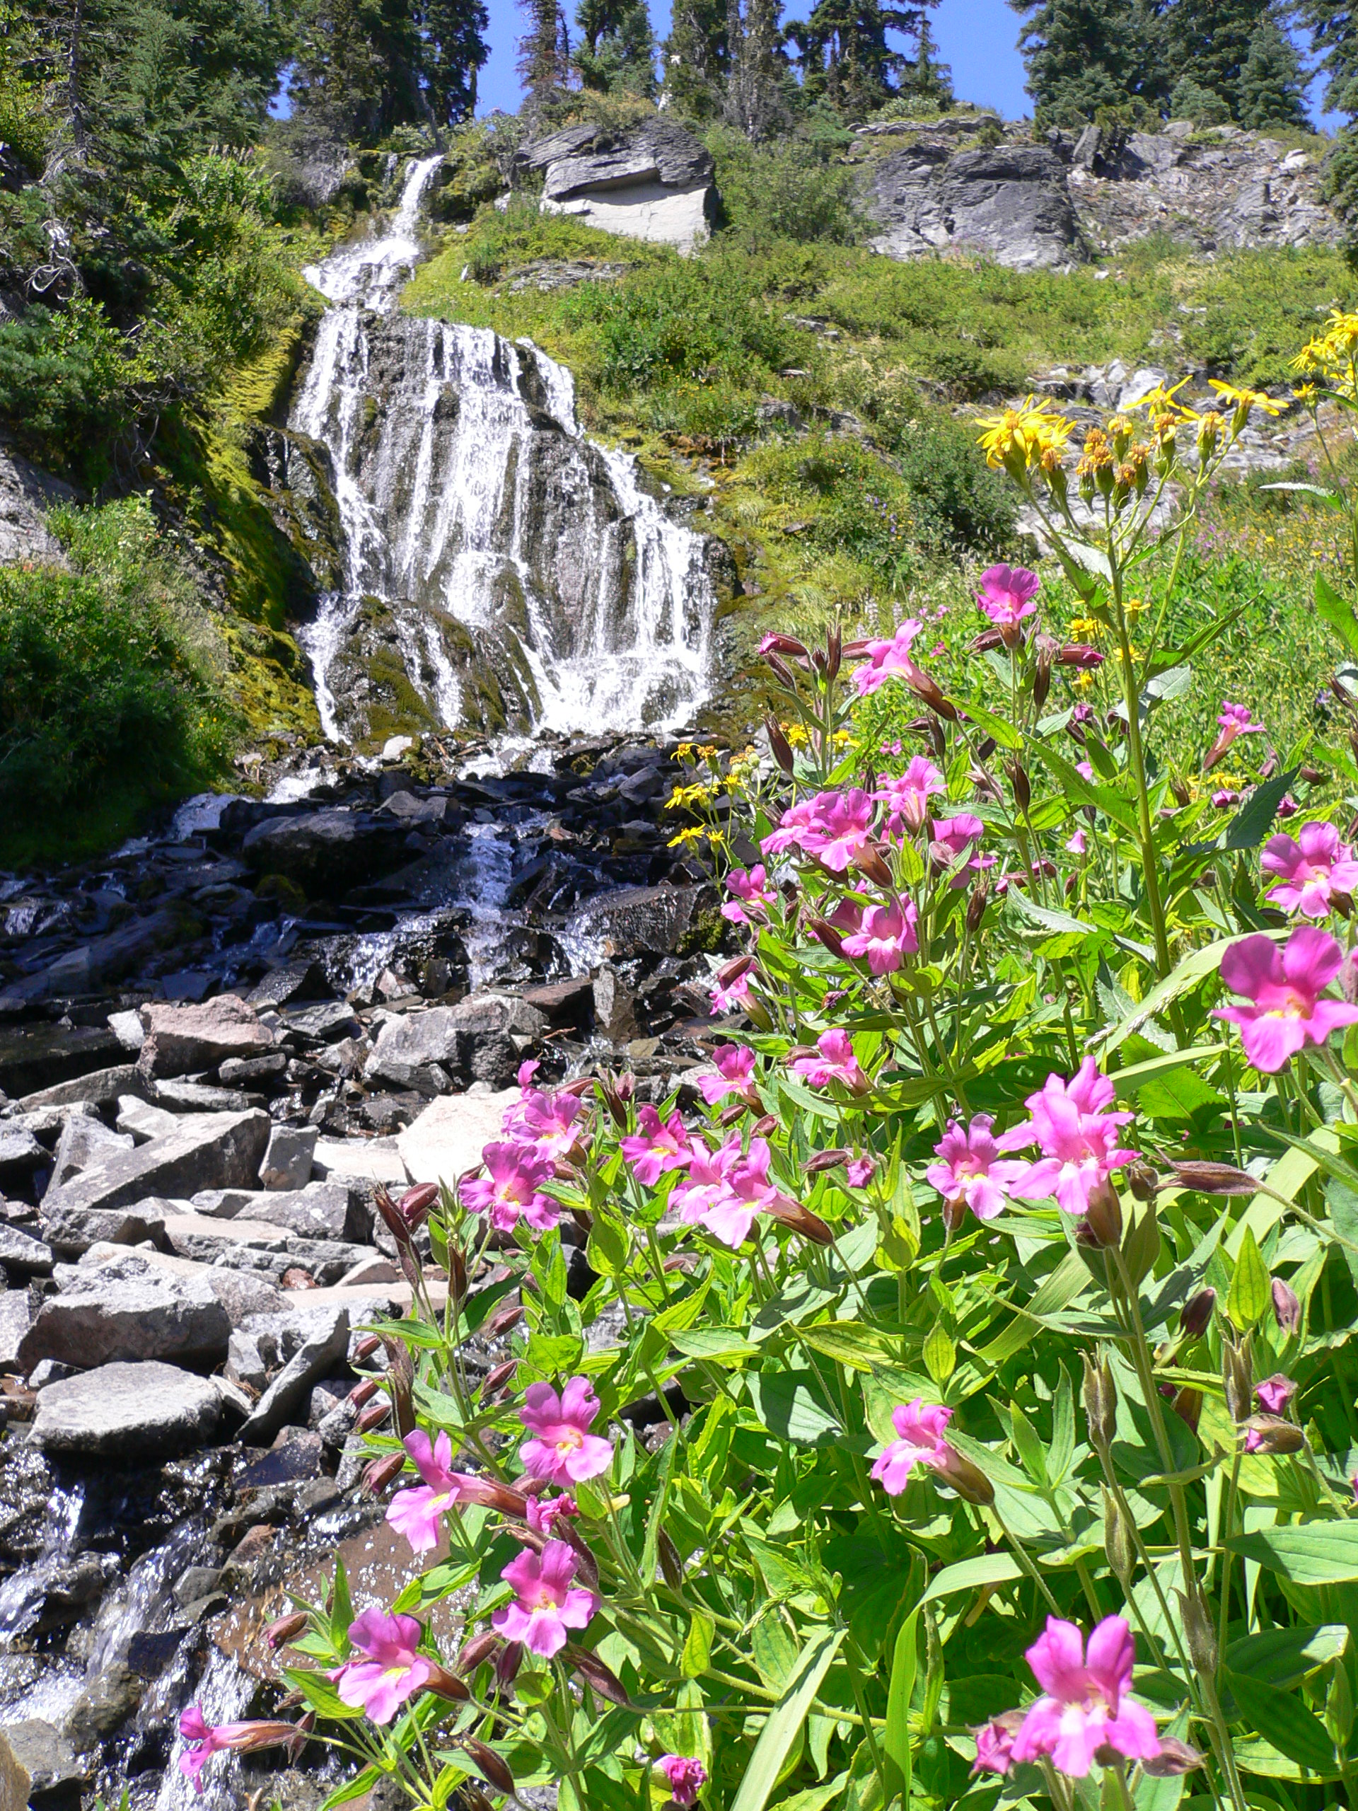

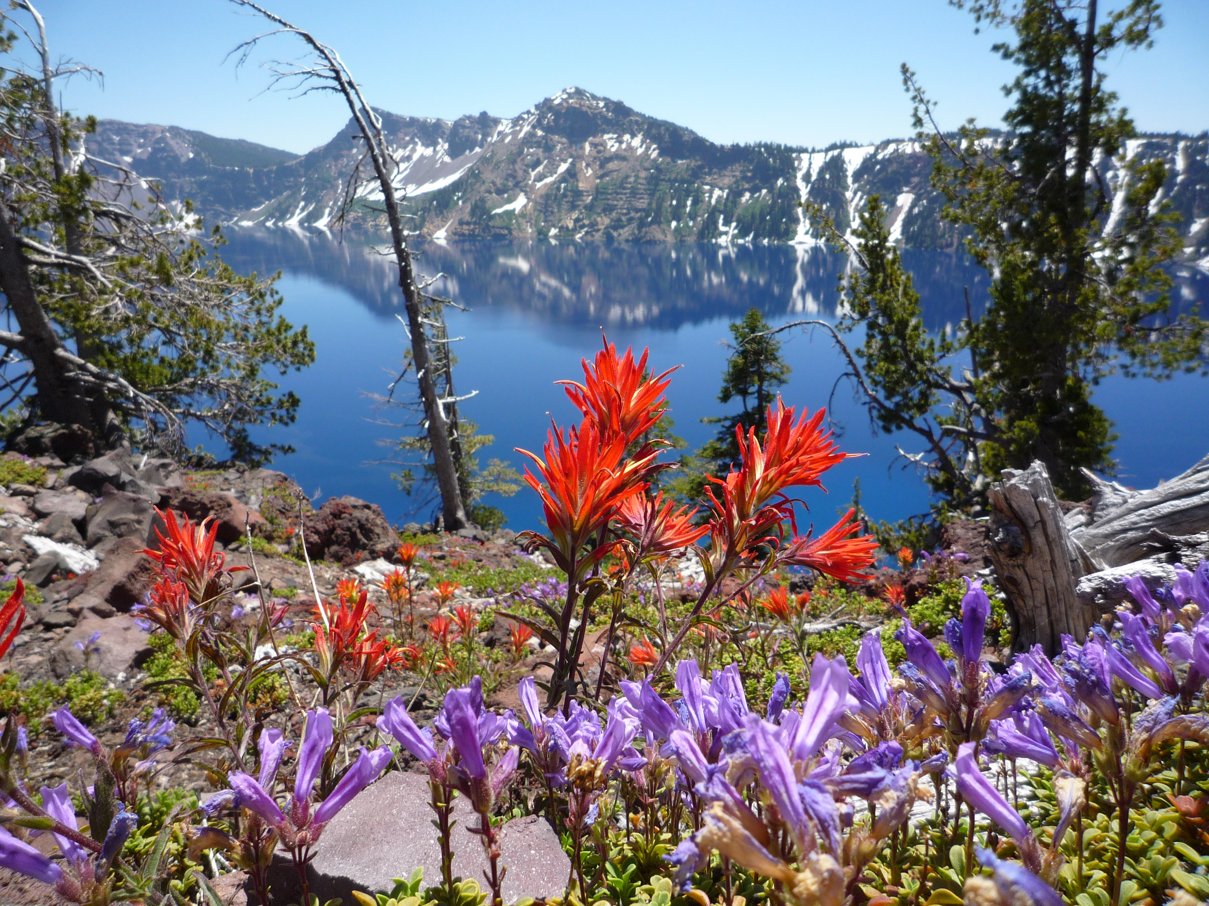

# Park Operating Hours

Crater Lake National Park is open year-round, 24 hours a day. Some roads, trails, and facilities, however, are closed seasonally due to snow. North Entrance Road, and West and East Rim Drives close for the season on November 1 (or earlier if there is significant snowfall). Crews begin removing snow from these roads in April, but opening dates vary. The North Entrance Road and West Rim Drive tend to open in early June. The East Rim Drive typically opens in early July.

# Contact Information

## Address

Crater Lake National Park  
1 Sager Building  
OR  
97604

# Website Info

https://national-parks-1150.azurewebsites.net/api/CRLA